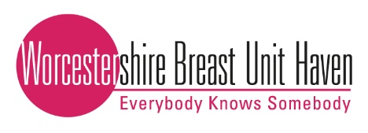
WBUH Perfectly Pink Ball Booking Form
Saturday 1st October 2022
Bank House Hotel, Bransford, Worcs, WR6 5JD
Black Tie and Ball Gowns
Contact Details
Lead Name
Phone Number
Email
Address for ticket distribution*
*Please indicate here if you can collect in person from WBUH. If not, tickets will be issued no later than two weeks before the event.
Tables required
No. of standard tables of 10 (@ £650) OR
No. of individual tickets (@£65 pp)

Guest names and dietary requirements (required for table plans)
Name | Vegetarian/Allergy info | Name | Vegetarian/Allergy info
1. |  | 6.
2. |  | 7.
3. |  | 8.
4. |  | 9.
5. |  | 10.
(Please write on the back of the form if you need more room)
Payment Details
Tickets £650 for a table of ten (£65 per ticket)
Payment Type | Tick
Cheque enclosed with booking form, payable to ‘Worcestershire Breast Unit Haven’
Bank Transfer - Worcestershire Breast Unit Haven Bank Details:
(Please use Lead Name & ‘Ball’ as reference so we can identify your payment)
Account Name: Worcestershire Breast Unit Haven
Bank: Handelsbanken
Sort Code: 40 51 62
Account Number: 88802661

N.B Given the current climate, in the unfortunate event we may not be able to go ahead with the ball due to Coronavirus, the ball will be moved to a later date at the same venue. Upon communication of the new date, if you are unable to attend, we will be able to offer a full refund per table if you have booked a full table or per ticket if you had booked individual tickets. We are unable to offer refunds in any other circumstance.
Please email your completed form to: clare.stokes3@nhs.net OR send to us in the post at: FAO Clare Stokes, Worcestershire Breast Unit Haven, PO Box 933, Worcester, WR4 4GN

For further information, please visit www.worcsbreastunithaven.com
For hotel rooms, please book directly via the Bank House Hotel:
W. www.bankhouseworcester.co.uk T. 01886 833 551 E. reception@bankhouseworcester.com
Thank you – we look forward to seeing you on the evening

